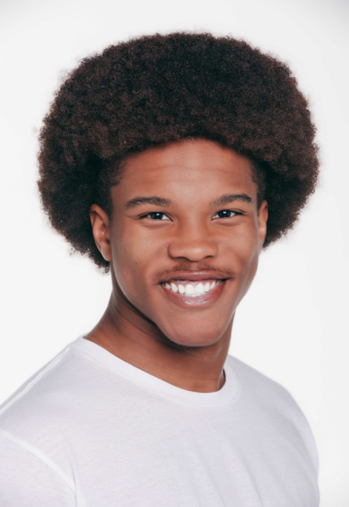Tyler O. Rice

He / Him

|  |
| --- |
| (205) 635-8003 |
| [tyler.rice929@gmail.com](mailto:tyler.rice929@gmail.com) |
| http://tylerricemodels.com |
| Height: 5’11” |
| African American |

|  |  |  |  |
| --- | --- | --- | --- |
| FILM |  |  |  |
| Jabari’s Log | Lead | Uni. Of Montevalllo | Dir: Tyson Evans |
| Home | Supporting | On The Set Film Camp | Dir: Bruce Cunningham Jr. |
| Thursday | Supporting | On The Set Film Camp | Dir: David Tucker |

|  |  |  |  |
| --- | --- | --- | --- |
| TV / WEB SERIES | |  |  |
| The Book of Tyson | Recurring | YouTube.com | Dir: Tyson Evans |

|  |  |  |  |
| --- | --- | --- | --- |
| THEATER |  |  |  |
| Pippin | Player (Ensemble) | University of Montevallo | David Callaghan |
| Pleasant Vanished - *(College Night Original)* | Ohmar (Ensemble) | University of Montevallo | Joshua Norris |
| Pill Hill | Al | University of Montevallo | Chalethia Williams |
| Cryptid Conspiracy - *(College Night Original)* | Wood Whisperer (Ensemble) | University of Montevallo | Olivia LeComte |
| The Crucible | John Proctor | Pinson Valley High School | John Bailey |
| Radium Girls | Arthur Roeder | Pinson Valley High School | John Bailey |
| A Raisin in The Sun | Bobo | Shades Valley High School | Carl Dean |

|  |
| --- |
| COMMERCIAL / VOICE-OVER |

LIST UPON REQUEST

|  |
| --- |
| EDUCATION / TRAINING |

**BFA in Acting,** University of Montevallo

**Acting:** David Callaghan, Marcus Lane, Carl Dean, John Bailey

**On-Camera:** David Tucker, Bruce Cunningham Jr.

**Voice & Speech:** Michael Walker

|  |
| --- |
| SPECIAL SKILLS |

Stunts (Intermediate) | Basketball (Beginner) | Football (Intermediate) | Singing (9 years) |

Stage Makeup (Beginner) | Dancing (Intermediate) | Improvisation (Beginner)